SPRINT-3

APPLICATION BUILDING CREATE HTML FILES

|  |  |
| --- | --- |
| DATE | 17 NOV 2022 |
| PROJECT NAME | CLASSIFICATION OF ARRHYTHMIA USING 2-D  ECG IMAGE SPECTRAL REPRESENTATION |
| TEAM ID | PNT2022TMID43833 |

**TASK**

**We use HTML to create the front and end part of the web page HTML CODE FOR THE HOME PAGE:**

<!DOCTYPE html>

<html>

<head>

<title>Home</title>

<style> body{

background-color:beige; background-size:1700px 903px; background-repeat:no-repeat; padding:0;

margin:0;

}

.navbar

{

margin: 0px; padding:20px; background-color:white; opacity:0.6; color:yellow;

font-family:'Roboto',sans-serif; font-style: italic;

border-radius:20px; font-size:25px;

}

a

{

color:red; float:right;

text-decoration:none; font-style:normal; padding-right:20px;

}

a:hover{

background-color:blue; color:red;

border-radius:15px;0 font-size:30px; padding-left:10px;

}

a{ color:red; float:right;

text-decoration:none; font-style:normal; padding-right:20px;} p{

font-color:"#3498eb"; font-style:italic;

font-size:30px;

font-family:Bell MT

}

</style>

</head>

<body bgcolor="black">

<div class="navbar">

<a href="/upload" >Predict</a>

<a href="/info">Info</a>

<a href="/types">Types</a>

<a href="/about">Home</a>

<br>

</div>

<center><b class="pd"><font color="black" size="15" font- family="Comic Sans MS" >ECG Arrhythmia classification using CNN</font></b></center>

<div>

<br>

<center>

<p><font color="black" background-color="#2596be">‘Hear Arrhythmia’ is the condition of irregular heart rhythms. There are variations in the heartbeat patterns. When electrical signals that were meant to coordinate with the heartbeats falter, this condition takes place. The heart could beat faster, or slower, or any other form of irregularity is usually noticeable. Some basic fluttery feeling is harmless. It may speed up during active periods of the body and slow down during relaxing periods. The level of symptoms is important to look for because some of them can even be life-threatening. There might not be obvious signs of Arrhythmia. One might need a medical professional to figure it out, but the subtle details to look for are;

</p>

<font color="black" size="5">

<head>

<style> div.container { text-align: center;

}

ol.myOL {

display: inline-block; text-align: left;

}

</style>

</head>

<body>

<div class="container">

<ol class="myOL">

<li>A fluttering feeling in the chest</li>

<li>The feeling of heartbeats slowing down or speeding up</li>

<li>Breathlessness</li>

<li>Pain in the chest area</li>

<li>Heavy sweating</li>

<li>Dizziness</li>

<li>Fatigue</li>

<li>Lightheadedness or fainting</li>

<li>Anxiety</li>

</ol>

</div>

</body>

</font>

</div>

</body>

</html>

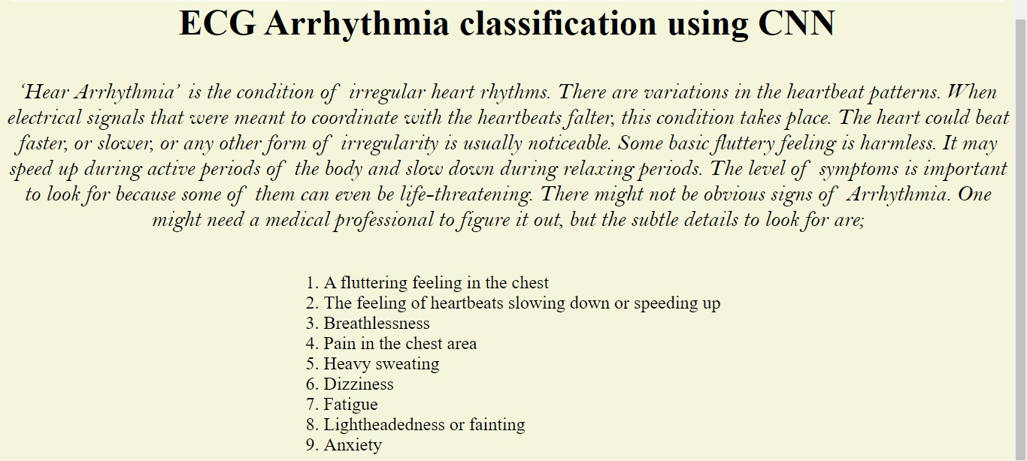

# HTML CODE FOR INFO PAGE

<!DOCTYPE html>

<html>

<head>

<title>Home</title>

<style> body{

background-color:beige; background-size:1700px 903px; background-repeat:no-repeat; font-family: "Comic Sans MS"; font-size: 15;

padding:0; margin:0;

}

.navbar

{

margin: 0px; padding:20px; background-color:white; opacity:0.6; color:yellow;

font-family:'Comic Sans MS'; font-style: italic;

border-radius:20px; font-size:25px;

}

a

{

color:red; float:right;

text-decoration:none; font-style:normal; padding-right:20px;

}

a:hover{

background-color:blue; color:red;

border-radius:15px;0 font-size:30px; padding-left:10px;

}

a{ color:red; float:right;

text-decoration:none; font-style:normal; padding-right:20px;} p{

font-color:"#3498eb"; font-size:30px;

font-family:Bell MT

}

</style>

</head>

<body bgcolor="black">

<div class="navbar">

<a href="/upload" >Predict</a>

<a href="/info">Info</a>

<a href="/types">Types</a>

<a href="/about">Home</a>

<br>

</div>

<br>

<center>

<b class="pd">

<font color="black" size="15" font-family="Comic Sans MS">Diagnosis of Arrhythmia</font>

</b></center>

<dl>

<b> <dt>1.Electrocardiograms (ECG)</dt>

<dd>Can detect electrical activity of the heart.</dd>

<dt>2.Echocardiograms</dt>

<dd>Uses sound waves to produce images of the heart.</dd>

<dt>3.Implantable loop recorder</dt>

<dd> It can be implanted under the skin around the heart, to record its status.</dd>

<dt>4.Event recorder</dt>

<dd>It’s like a wearable ECG. It is supposed to be alerted when you have symptoms. </dd>

<dt>5.Holter Monitor</dt>

<dd>It’s another mobile ECG device which is temporarily used to record the activity of the heart.</dd></b>

</dl>

<p><b>

<font color="black" background-color="#2596be" size="5" font- family="Comic Sans MS" >Other tests that can be used are, Stress test, where you are made to do a physical activity and the activity of your heart is recorded. Tilt-table test is used for fainting cases, where

you lie flat on the table while recording your heart status. EP testing and mapping can also be used where tubes with electrode ends are used inside your body to find details.

</p></b>

<center><b class="pd">

<br >

<font color="black" size="15" font-family="Comic Sans MS">Treatment -Medications</font>

</b></center>

<p><b>

<font color="black" background-color="#2596be" size="5" font- family="Comic Sans MS">Drugs like blood thinners are recommended by doctors as per the condition of the patient.There are two therapies to treat heart issues-</font>

</p></b>

<dl>

<dt>1.Cardioversion</dt>

<dd>Shock is delivered to the heart using patches on the chest which coordinates the electrical impulses.</dd>

<dt>2.Vagal maneuvers</dt>

<dd>Controls the nervous system, which inturn slows down the heart beats. Used for faster heart beat conditions.</dd>

</dl>

<center><b class="pd">

<br />

<font color="black" size="15" font-family="Comic Sans MS">Surgeries</font>

</b></center>

<div>

<br>

</div>

<ol>

<li>Catheter ablation: Catheters are used in the blood vessels connected to the heart.

<li>

Pacemaker: It is a tiny device implanted near the collarbone.

</li>

<li>

Maze procedure: It involves making multiple pattern like incisions of the heart tissue to make it scar tissue which reduces the stray electrical impulses.

</li>

<li>ICD: It is also a device implanted under the skin of the collarbone.</li>

<li>Coronary bypass surgery: It improves the flow of blood to your heart.</li>

</ol>

<br />

<center>

<b> <font color="black" size="15" font-family="Comic Sans MS">Home Remedies</font></center> </b>

<div>

<br>

</div>

<ol>

<li>Eat healthy</li>

<li>Do not smoke or drink</li>

<li>Exercise regularly, keep your weight in check</li>

<li>Keep your blood pressure and cholesterol levels in check</li>

<li>Keep proper habits of medication and doctor visits whenever necessary</li>

<li>Do Yoga, Meditation, and other Relaxation techniques</li>

</ol>

<br />

<center>

<b> <font color="black" size="15" font-family="Comic Sans MS">Precautions</font></center> </b>

<div>

<br>

</div>

<ol>

<li>Have healthy practices</li>

<li>Keep note of any symptoms you’re having</li>

<li>Be aware of the conditions</li>

<li>Have proper doctor visits</li>

<li>Make a list of all the medications and family history of Arrhythmias</li>

</ol>

<br />

</style>

</body>

</html>

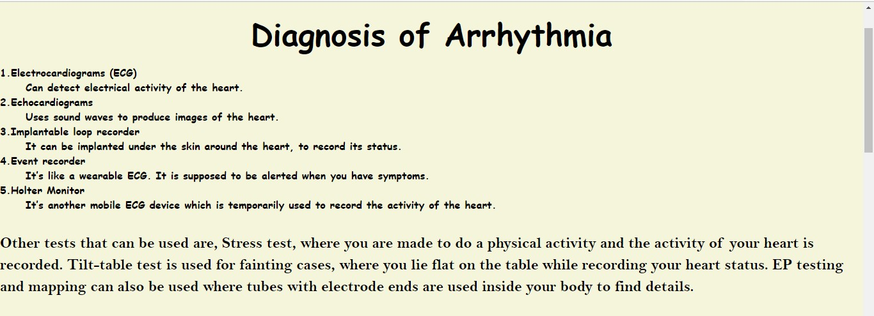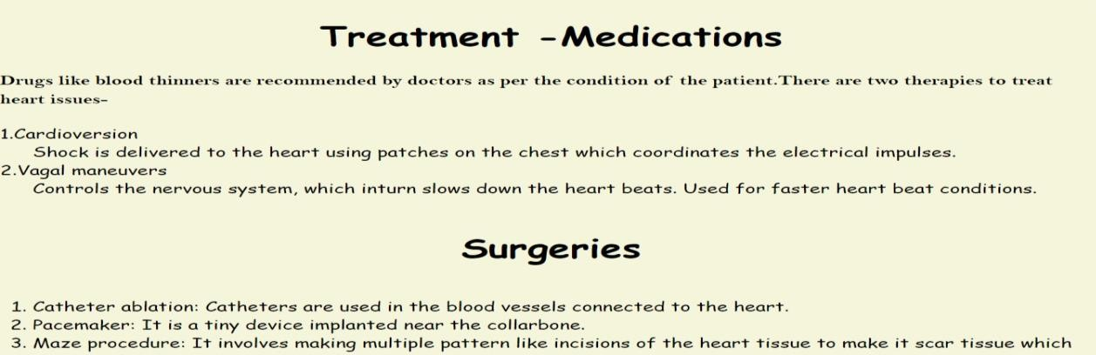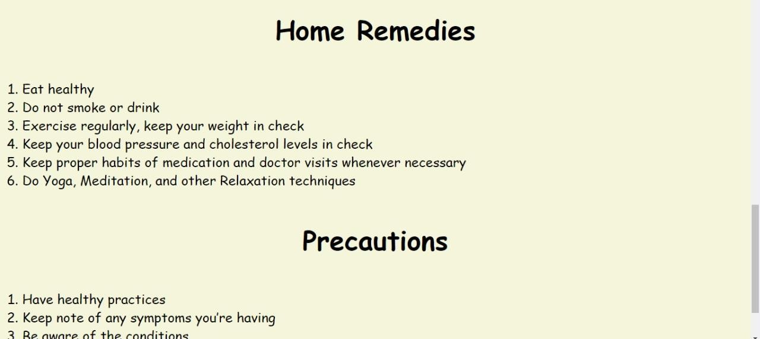

# HTML CODE FOR PREDICT BASE PAGE

<html lang="en">

<head>

<meta charset="UTF-8">

<meta name="viewport" content="width=device-width, initial- scale=1.0">

<meta http-equiv="X-UA-Compatible" content="ie=edge">

<title>Predict</title>

<link href="https://cdn.bootcss.com/bootstrap/4.0.0/css/bootstrap.min.css" rel="stylesheet">

<script src="https://cdn.bootcss.com/popper.js/1.12.9/umd/popper.min.js"></ script>

<script src="https://cdn.bootcss.com/jquery/3.3.1/jquery.min.js"></script>

<script src="https://cdn.bootcss.com/bootstrap/4.0.0/js/bootstrap.min.js"></sc ript>

<link href="{{ url_for('static', filename='css/flask_main_style.css')

}}" rel="stylesheet">

<style>

.bar

{

margin: 0px; padding:20px; background-color:white; opacity:0.6;

color:black;

font-family:'Roboto',sans-serif; font-style: italic;

border-radius:20px; font-size:25px;

}

a

{

color:grey; float:right;

text-decoration:none; font-style:normal; padding-right:20px;

}

a:hover{

background-color:black; color:white;

border-radius:15px;0 font-size:30px; padding-left:10px;

}

</style>

</head>

<body>

<div class="bar">

<a href="/upload" >Predict</a>

<a href="/info">Info</a>

<a href="/types">Types</a>

<a href="/about">Home</a>

<br>

</div>

<body style="background-color:beige">

<div id="maintext" style="position:absolute; margin:auto; width:700px; height:200px; text-align:center; top:0; bottom: 200; left: 0; right: 0;">

<h1 class="text mb-2" > Upload your image to be classified! </h1>

<h4 class="text-brown mb-5" >(Please upload images less than 500kb in size)</h4>

<div class="wrapingimage">

<img src="https://[www.kindpng.com/picc/m/545-5451776_doctor-](http://www.kindpng.com/picc/m/545-5451776_doctor-) png-clipart-funny-doctor-cartoon-png-transparent.png" class="right"

width="250"

height="250" align="right">

<br>

<div style="border:green; border-width:2px; border-style:solid;">

<p align="left"class="text mb-2"> Would you like your heart beat pattern to be analysed?</p>

<p align="left" > Then, you have come to the right place!</p>

<p align="left"> Know your heart with a single click!</p>

<p align="left"> Please direct to the previous pages for more information</p>

</div>

<br>

<br>

<div class="container">

<center> <div id="content" style="margin-top:2em">{% block content %}{% endblock %}</div></center>

</div>

</body>

<footer>

<script src="{{ url_for('static', filename='js/flask_main_js.js') }}" type="text/javascript"></script>

</footer>

</html>

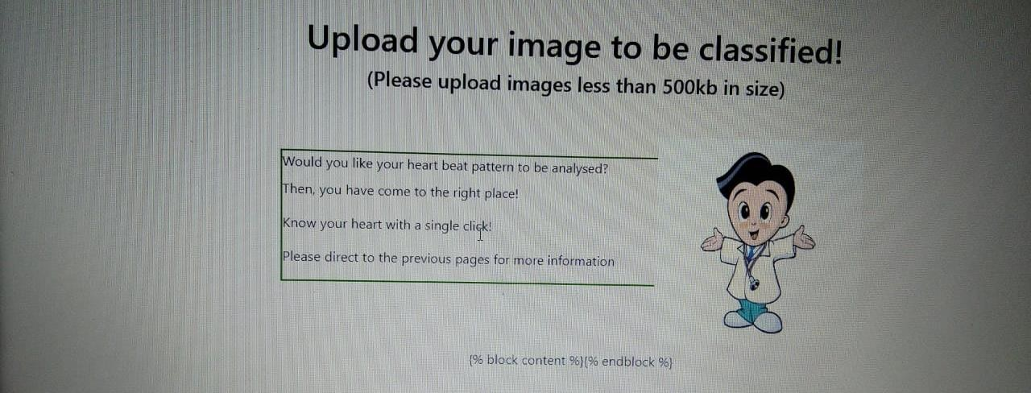

# HTML CODE FOR TYPES:

<!DOCTYPE html>

<html>

<head>

<style> body{

background-color:"beige";

background-size:1700px 903px; background-repeat:no-repeat; font-family: "Comic Sans MS"; font-size: 15;

padding:0; margin:0;

}

.navbar { margin: 0px; padding: 20px;

background-color: white; color: yellow;

font-family: Comic Sans MS; border-radius: 20px;

font-size: 25px;

}

a {

color: red; float: right;

text-decoration: none; font-style: normal; padding-right: 20px;

}

a:hover {

background-color: blue; color: red;

border-radius: 15px; font-size: 30px; padding-left: 10px;

}

a {

color: red; float: right;

text-decoration: none; font-style: normal; padding-right: 20px;

}

p {

font-color: "#3498eb"; font-size: 30px;

font-family: Bell MT

}

</style>

</head>

<body bgcolor="black">

<div class="navbar">

<a href="/upload">Predict</a>

<a href="/info">Info</a>

<a href="/types">Types</a>

<a href="/about">Home</a>

<br>

<center><b class="pd">

<font color="black" size="15" font-family="Comic Sans MS">Types of Arrhythmia</font>

</b></center>

<div>

<br>

<center>

<p>

<b> <font color="black" background-color="#2596be" size="5" font- family="Comic Sans MS">Arrhythmias are usually categorized based on the speed of heart rate. The three main categories would be-

Tachycardia: Fast heartbeats (heart rate greater than 100 beats per minute)

Bradycardia: Slow heartbeats (heart rate slower than 60 beats per minute)

Premature heartbeats</b>

</p>

</center>

<style>

.wrapingimage { float: right;

margin: 30px 12px 3px 4px;

}

img {

display: block; margin-left: auto; margin-right: auto;

max-width: 20%;

height: 50%;

}

</style>

<img src="/static/page2.jpeg" class="center">

<b class="pd">

<font color="black" size="6" font-family="Comic Sans MS" align="left">Tachycardia: Fast heartbeats</font>

<p>

<font color="black" background-color="#2596be" size="5" font family="Comic Sans MS">There are five types of Tachycardias. They differ in patterns.

</p>

</b>

<dl>

<dt>1.Atrial Fibrillation</dt>

<dd>This is a rapid and uncoordinated beating of the heart. It’s caused by the chaotic signaling of the heart. It might even lead to a stroke. It has to be treated.</dd>

<div class="wrapingimage">

<img src="/static/img1.1.jpeg" class="center">

<dt>2.Atrial Flutter</dt>

<dd> It is very similar to Atrial Fibrillation, but the patterns seem to be more organized in Atrial flutter. This might also cause a stroke.</dd>

<style> img {

display: block; margin-left: auto; margin-right: auto;

}

</style>

<img src="/static/img1.2.jpeg" class="center">

<dt>3.Supraventricular Tachycardia</dt>

<dd>This causes the abrupt episodes of palpitations. They are related to the ventricular regions of the heart.</dd>

<img src="/static/img1.3.jpeg" class="center">

<dt>4.Ventricular Fibrillation</dt>

<dd>This removes the coordination of the ventricles pumping blood, and makes it chaotic and rapid. Serious traumatic experiences or long- term heart problems can be causes for this. It can be deadly if left untreated for longer than a few

minutes.</dd>

<img src="/static/img1.4.jpeg" class="center">

<dt>5.Ventricular Tachycardia</dt>

<dd>

The rapid beats are organized but they do not allow the ventricles to pump enough blood to the body. It is not very harmful to healthy people, but those suffering from heart conditions must get help quickly.

</dd>

</dl>

<img src="/static/img1.5.jpeg" class="center">

<b class="pd">

<font color="black" size="6" font-family="Comic Sans MS" align="left">Bradycardia: Slow heartbeats</font>

</b>

<p>

<b> <font color="black" background-color="#2596be" size="5" font- family="Comic Sans MS">A slow heart rate causing your heart to not pump enough blood is Bradycardia major problem. It has two types.

</b> </p>

<dl>

<dt>1.Sick Sinus</dt>

<dd>Scarring happens near the sinus node and slows down impulses. It might cause disruptions or blockages too. It’s commonly seen in older people.</dd>

<img src="/static/img2.1.jpeg" class="center">

<dt>2.Conduction block</dt>

<dd>The electrical pathways are blocked and thus heartbeats can slow down or may even stop. Skipped heartbeats are a common symptom.

This may even be symptomless.

</dd>

<img src="/static/img2.2.jpeg" class="center">

</dl>

<b class="pd">

<font color="black" size="6" font-family="Comic Sans MS" align="left">Premature heartbeats</font>

</b>

<p>

<b> <font color="black" background-color="#2596be" size="5" font- family="Comic Sans MS">This is a condition of extra heartbeats.

This usually occurs in certain patterns alternatively with the normal beating of the heart. The cause could be

atrial or ventricular. Stress,

extreme exercising, or intake of caffeine or nicotine may cause it. It might feel like your heart skipped a beat. They are usually not serious conditions, but in chronic cases, they must get checked out.

</p></b>

<img src="/static/img3.jpeg" class="center">

</div>

</body>

</html>

